

**REPORT ON PROJECT - WEATHER.io APPLICATION**

WEATHER APP



**INTRODUCTION**

Weather forecasting is the science and technology to predict the conditions of the atmosphere at a particular place. Human beings have attempted to predict the weather since the 19th century. Earlier, weather forecasting was mainly done by predictions and they were not very accurate. With the development in science and technology, scientists can now predict the weather to a much higher accuracy. The Weather App is a front-end project aimed at providing real-time weather information to users. This report will discuss the development process, features implemented, and future scope of the Weather App.

**Overview:**

A weather app is an application that provides users with real-time weather information, forecasts, and other related data. It allows users to check the current temperature, humidity, wind speed, precipitation, and other weather conditions, along with the forecast for upcoming days. Weather Prediction is made by collecting quantitative data about the current state of the atmosphere, land, ocean and using meteorology to project how the atmosphere will change at a given place. The Weather App project is a web application that leverages HTML, CSS, and JavaScript to fetch weather data from a weather API and display current weather conditions and forecasts for a specific location. It provides users with real-time weather information, allowing them to stay informed about the weather conditions in their desired location.

**Purpose:**

The purpose of a weather app is to offer convenience and accessibility to users who want to stay updated with accurate weather information on the go. It enables users to plan their activities, make informed decisions, and prepare for weather-related events. Knowing about weather is very crucial, since it helps to determine future climate changes. With the use of latitude, we can determine the probability of snow and hail reaching the surface. We are able to identify the thermal energy from the sun that is exposed to a region. It is also used to protect lives and property.

**LITERATURE SURVEY**

During the development process, a literature survey was conducted to understand existing weather applications and their features. Some popular weather apps analysed were AccuWeather, Weather Underground, and The Weather Channel. These apps offered features such as current weather conditions, hourly and daily forecasts, radar maps, and severe weather alerts. The strengths of these apps included comprehensive data, user-friendly interfaces, and reliable forecasts. However, some limitations included intrusive ads and limited customization options.

**Existing Problem**:

One common problem with weather apps is the accuracy of the information provided. Sometimes, these apps rely on data from unreliable sources, leading to inaccurate weather forecasts and conditions. Additionally, some apps may have a cluttered user interface or lack user-friendly features, which can make it difficult for users to navigate and find the information they need.

**Proposed Solution:**

To address the existing problem, the proposed solution is to develop a weather app that utilizes reliable and accurate weather data sources. This can include partnering with reputable meteorological organizations and leveraging advanced weather forecasting models. The user interface should be intuitive and easy to navigate, with essential weather information prominently displayed. App developers should also incorporate additional features such as severe weather alerts, hourly forecasts, and customizable settings to enhance the user experience.

**THEORITICAL ANALYSIS**

**BLOCK DIAGRAM:**

USE CASE DIAGRAM OF WEATHER APPLICATION: ACTIVITY DIAGRAM OF WEATHER APPLICATION:

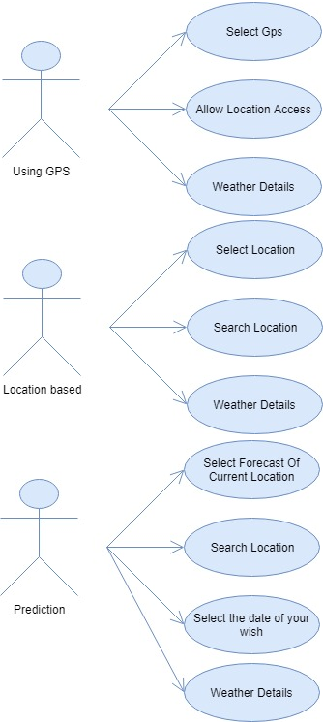 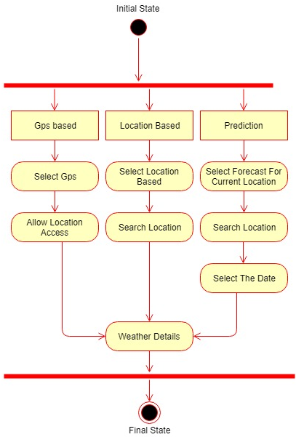

**Hardware and Software Requirements:**

**Hardware Required**

* Standard computer with at least i3 processor Standard computer with 4GB of RAM
* Standard computer with 100GB of free space.
* Active Internet Connectivity with good bandwidth.

**Software Required**

* Visual Studio Code
* Ms Office
* HTML
* CSS
* Java Script

**SOURCE CODE IMAGES:**

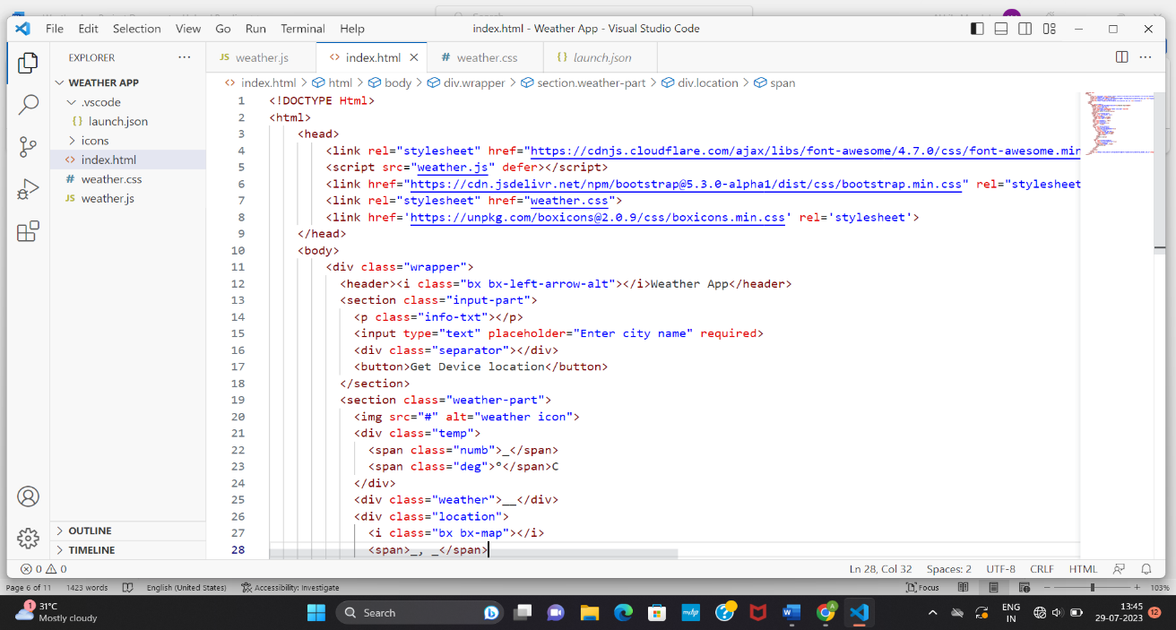

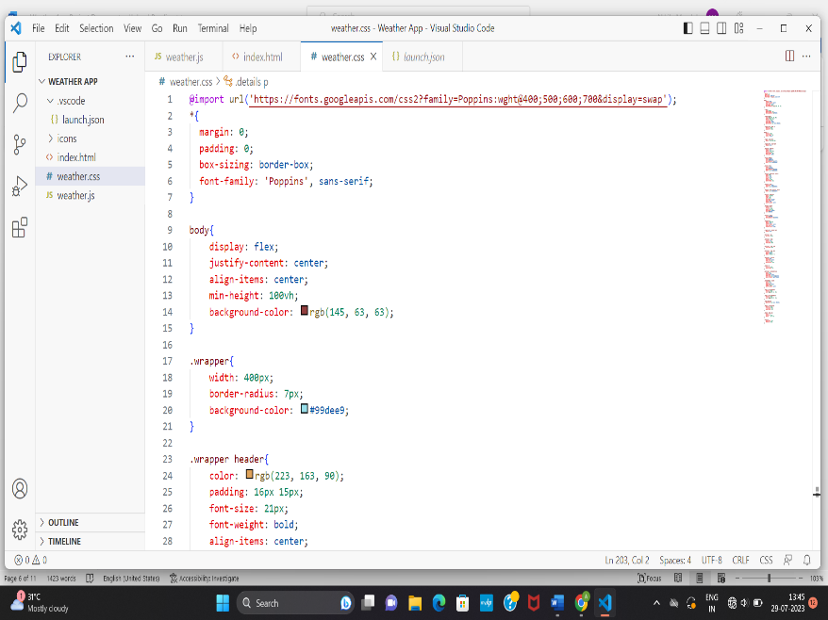 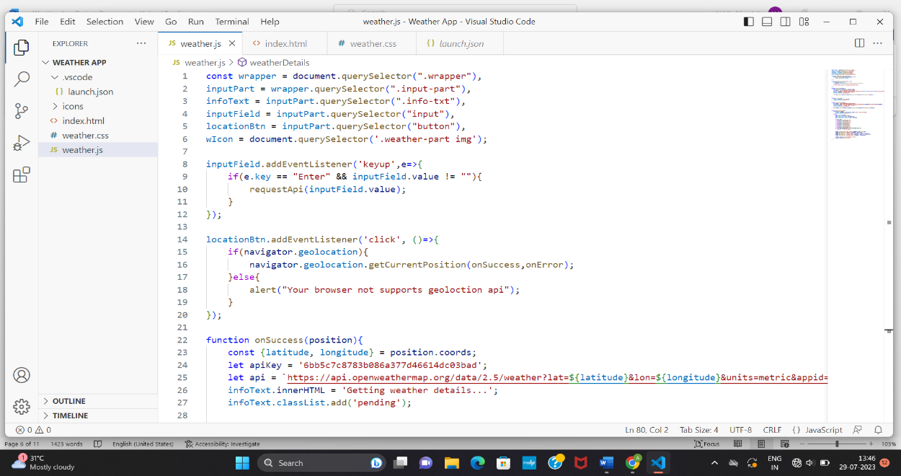

**RESULT (OUTCOME)**

The Weather App successfully provides users with accurate and up-to-date weather information for their chosen location. The app's interface is intuitive and responsive, ensuring a seamless user experience. The weather data obtained from the API is displayed in a visually appealing manner, with weather icons representing different weather conditions.

The following are the output of the Weather application developed.

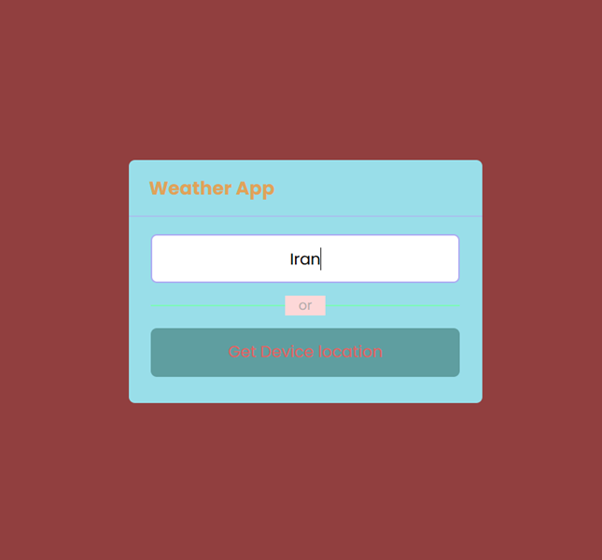 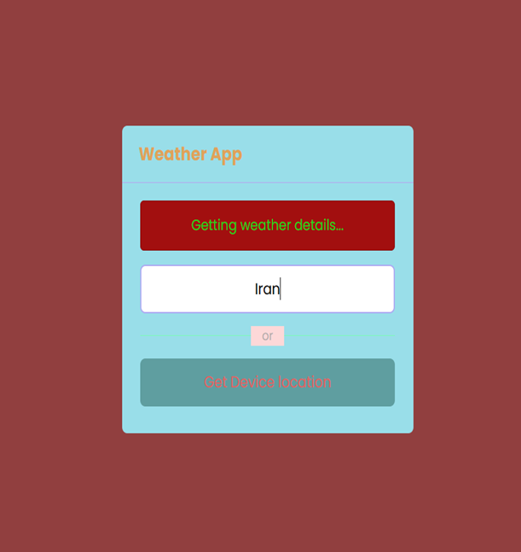

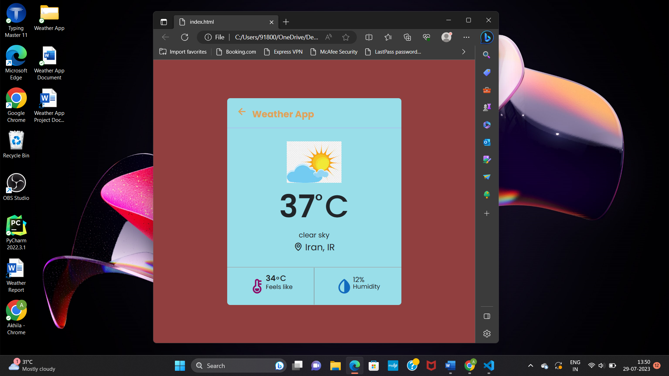 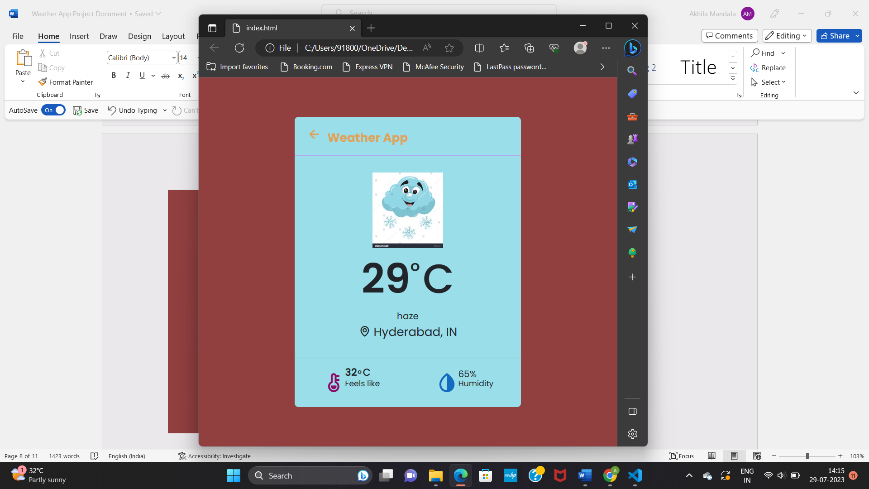

By implementing the proposed solution, the weather app can provide users with accurate and reliable weather information, enabling them to plan and prepare accordingly. Users will have access to real-time updates, helping them make informed decisions and avoid weather-related inconveniences. The app's user-friendly interface and additional features will enhance the overall user experience, making it a preferred choice among users.

**ADVANTAGES**

* **Real-time Weather Information:** Users can obtain up-to-date weather data for any desired location, enabling them to make informed decisions based on current and forecasted weather conditions.
* **User-friendly Interface:** The application offers a clean and intuitive interface for entering locations and viewing weather information. It presents data in a clear and organized manner, enhancing the user experience.
* **Planning and Preparedness:** The Weather App allows users to plan their activities and make informed decisions based on weather forecasts. They can adapt their schedules, clothing, or travel plans accordingly, enhancing safety and convenience.
* **API Integration:** By integrating with a weather API, the app can leverage the data and capabilities provided by the API, ensuring accurate and reliable weather information.

**DISADVANTAGES**

* **Dependency on internet access:** Weather apps rely on internet connectivity to fetch real-time data. Users may face difficulties accessing accurate weather information in areas with weak or no internet connectivity.
* **Battery drain:** Weather apps constantly update in the background to provide up-to-date forecasts, which can consume significant battery power.
* **Data usage:** Users with limited data plans may find weather apps consuming a significant portion of their data allowance due to frequent updates and map downloads.
* **Limited accuracy:** Although efforts are made to improve accuracy, weather forecasting is still subject to uncertainties. Users should be aware that occasional inaccuracies or deviations from the forecast may occur.
* **Privacy concerns:** Some weather apps may collect and use personal data for targeted advertisements or other purposes. Users should review the app's privacy policy before providing any sensitive information

**APPLICATIONS**

A weather app has a wide range of applications and can benefit various users in different ways. It is useful for individuals who engage in outdoor activities like hiking, camping, or sports, as they can plan their activities based on weather conditions. It is also valuable for travellers, helping them prepare for different weather conditions at their destination. Farmers can utilize weather apps to make informed decisions regarding their agricultural practices. Additionally, weather apps are valuable for businesses in industries such as transportation, logistics, and construction, as they can plan their operations accordingly.

Weather also controls the distribution of rain water flow on the earth. Some weather apps may have extended functionality, like tracking of ocean tides or the skies.

**CONCLUSION**

In conclusion, the development of the Weather App has provided users with an easy-to-use interface for accessing weather information. The app effectively fetches and displays real-time weather data, ensuring users stay informed about current conditions and upcoming forecasts. The Weather App has the potential to benefit a wide range of users, including travellers, outdoor enthusiasts, and individuals planning their daily activities. Also, weather forecasts are increasingly accurate and useful, and their benefits extend widely across the economy. While much has been accomplished in improving weather forecasts, there remains much room for improvement. The forecasting community is working closely with multiple stakeholders to ensure that forecasts and warnings meet their specific needs

**FUTURE SCOPE**

The Weather App can be further enhanced with the following features:

* 1. **Geolocation**: Implement automatic location detection based on the user's device, allowing weather information to be directly displayed without the need for manual location input.
* 2. **Customization**: Provide users with options to customize the app's appearance, including background images, colour themes, and font styles.
* 3. **Notifications**: Integrate push notifications to provide users with severe weather alerts, updates on weather changes, or personalized weather recommendations based on their preferences.
* 4. **Historical Data**: Incorporate historical weather data to allow users to view past weather patterns and compare them with current conditions.
* 5. **Social Sharing**: Enable users to share weather information or forecasts with their friends and social networks through various platforms.

The future scope of weather apps is promising, with potential advancements and innovative features to be incorporated. One possibility is to integrate artificial intelligence (AI) algorithms to improve weather predictions and enhance the accuracy of forecasts. This can include machine learning models that analyse historical data, atmospheric patterns, and various other factors. Additionally, augmented reality (AR) can be integrated into weather apps to provide users with a more immersive experience, allowing them to visualize weather conditions in real-time. Future weather apps can also incorporate social features, allowing users to share weather information and updates with their friends and family.